**Project Report On**

**JOB FINDER**



**As partial fulfillment of**

**Bachelor of Computer Application**

**[B.C.A SEM-6 2023-2024]**

**Submitted to,**

**MATRUSHRI VIRBAIMA MAHILA COLLEGE OF COMMERCE MGMT. & IT.**

**Affiliated to,**

**SAURASHTRA UNIVERSITY, RAJKOT**

**Project Guide: Mr. Niraj Tanna**

**Submit By: Mayushi Girishbhai Ramani [21bca102]**

**Krishna Dineshbhai Padaliya [21bca086]**

**Rutva Dikeshbhai Sorathiya [21bca124]**

Approval of Title

**“JOB FINDER”**

The days of walk-in application for jobs have passed. People no more queue up to getting a meeting with a recruiter and hand them their resume personally. While it requires a lot of space and time, that process is just not efficient enough.

While now that we have the technology to support our businesses, it has also proven a helpful tool in conducting job searches. Today, most of the leading companies have their own dedicated JOB FINDERs that help them conduct the recruitment process without hiccups. JOB FINDERs are online platforms that provide job boarding solutions and helps job seekers to apply for posts that they are suitable for.

JOB FINDERs, are modern versions of job boards. These sites allow job seekers to post their applications online and apply to posts which they deem suitable to their career track. Similarly, it also lets firms review posted resumes and find qualified candidates for the job. JOB FINDERs also make it possible for firms to reach as much candidates as possible for their job vacancies.

**Preface**

We would like to state that the project is very essential part of our education portion.

We are honour to presenting this project report in **BCA semester 6th at MATUSHRI VIRBAIMA MAHILA COLLEGE OF** **COM., MGT & IT.** The topic of project is **“JOB FINDER”.** This preface shows highlight of our project so, you can give your valuable review is to us.

We made this file because, if any non-technical person read this, they can understand that we are mentioned over here.

Project report is just outstanding experience for us. Because we learn that how to explain our point of view in front of all audience which are came from non-IT backgrounds. We learn the easy and simple language that all the audience can understand our motive.

By preparing this project we have understood the need of practical training in the education field.

**Index**

|  |  |  |
| --- | --- | --- |
| **Sr No.** | **Title** | **Page No.** |
| 1 | Acknowledgement | 1 |
| 2 | Project Profile | 2 |
| 3 | Technology Study   * About Front Side * About Back Side | 3 |
| 4 | Timeline Chart | 8 |
| 5 | SDLC Stage Implementation  Preliminary Investigation  System Analysis  System Design  A] Data Dictionary  B] DFD/Data Flow Diagram  C] ER Diagram  D] Unnormalization  E] Normalization | 9 |
| 6 | Client Site | 32 |
| 7 | Admin Site | 40 |
| 8 | System Testing | 46 |

**Acknowledgment**

It was a great pleasure working on Online **JOB FINDER** which is donesemester 5th of B.C.A. We would like to mention here that this project would not possible without the support and guidance of our professors.

As the final frontier toward achieving a **B.C.A.** the activity of going through IT project has bridge the gap between the academic and practical real-life work for us. It has prepared us to apply ourselves to become good IT professional.

On the even of completion of our project regarding JOB FINDER.

The project has been prepared by us. This is good opportunity to shows our codding talent which was learn by us during our whole journey of our B.C.A degree.

Our faculties are extremely good. They are guide us for our project as well as study. Our project guide (MR. NIRAJ TANNA) helps us through their suggestions.

**Project Profile**

**Project title:** JOB FINDER

**Hard Disk Use**: 16.0GB RAM,

64-Bits operating System,

x64 based processor

**Operating system**: Windows 10

**Front end**: ASP.NET

**Back end**: SQL Server

**Software use**: Microsoft word

Microsoft visual studio 2008

**Browser**: Google chrome

**Project guide:** Mr. Niraj Tanna

**Project duration**: 3 Month

**Submitted by**: Padaliya Krishna

Ramani Mayushi

Sorathiya RutvaTools and technology study

## **About front end**

* Introduction ASP.NET

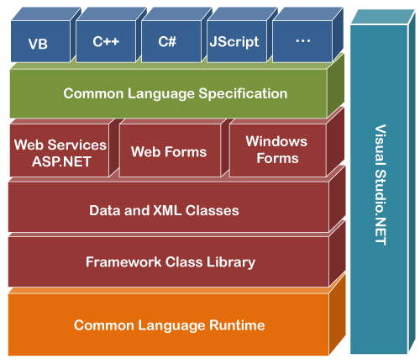

NET Framework

The .Net Framework helps software developers and systems administrators more easily build and maintain systems with improvement towards performance, security and reliability

## Benefits of the .Net Framework

The key advantages of the .Net Framework include that it

* Helps IT Professionals better integrate existing systems with its native
* Support for web services. Assists with the deployment of software to both users and web servers.
* Facilitates the development of software with improved reliability,
* Scalability, performance and security. Helps developers be more productive by,
* Making it easier for them to reuse existing code
* Enabling them to more easily integrate components written in any of the more than 20 supported programming languages.
* Helping them more easily build software for a wide range of devices using some skills and tools.

## **What is ASP .NET?**

ASP .NET is a programming framework built on the common language runtime that can be used on a server to build powerful web applications. ASP .NET offers several important advantages over previous web development models.

## **Features of Asp .Net**

* Enhanced Performance
* Word-Class Tool Support
* Power and Flexibility
* Simplicity
* Security
* Customizability and extends

## **About Back End**

## SQL Server

* Microsoft SQL is the most widely used database in the word. Microsoft SQL is relational database.
* This concept is extremely simple way of thinking about and managing data used in business.
* Microsoft SQL 2008 was developed and defines by Microsoft Corporation.
* Rather than manipulating single records you can manage sets of records the most common form of set of record is table.
* All SQL statement accepts sets as input and all SQL statement to be used as input to other SQL statement.
* SQL provide statements for a variety of tasks including: --
* querying data.
* Insert, update, delete database objects.
* create modifying, delete database objects.
* controlling access to database and database objects.
* Guaranteeing database consistence

Time Line Chart

|  |  |  |  |  |
| --- | --- | --- | --- | --- |
| **Task No** | **Task Name** | **Start Date** | **End Date** | **Duration** |
| 1 | System study | 20-10-23 | 10-12-23 | 32 days |
| 2 | Feasibility study | 11-12-23 | 23-12-23 | 13 days |
| 3 | System Design | 24-12-23 | 10-1-24 | 18 days |
| 4 | Coding | 11-1-24 | 2-2-24 | 22 days |
| 5 | Testing | 3-2-24 | 9-2-24 | 7 days |
| 6 | Implementation | 10-2-24 | 12-2-24 | 3 days |
| 7 | Final Testing | 13-2-24 | 14-2-24 | 2 days |

Chart:

SDLC Stage wise Implementation

**1] Preliminary Investigation: -**

A] Information Gathering:

For getting JOB FINDER related information we checked many job-related websites and collect information about this website.

B] Requirement Analysis:

Requirement Analysis is critical to the success or failure of system software project.

* **Technical Physibility:**

This phase gives technical information about used hardware and software in our project.

1. Editor:visual studio 2008
2. Browser:Google chrome
3. Server: Internet information services
4. Back end**:** SQL server
5. Front end: ASP.NET
6. RAM:4GB (3.87 GB usable)
7. Hard Disk: 64-bit operating system x64-Based processor
8. Processor: Intel(r) core(tm) i3 7020u CPU @2.30 GHZ
9. Screen:17 inches
10. Device: Mouse, Keyboard

* Economical physibity:

This phase is given information about hardware and software which was used in our project.

1. Software use: Microsoft academic alliance campus license all Microsoft products.
2. Software price:15,000 RS
3. Hardware price:35,000 RS
4. Operating system:Windows 10

* Request Approval:

Analysis approved the demand of user and ready to developed the project.

We can go through the investigation process and agree to developed the project.

1. System Analysis: -

**A] Manual System:**

In manual system we need to explain about JOB FINDER information.

**B] Proposed System:**

In propose system any job seeker visit to our website.

If any job seeker came to the website, they gain a true information about any jobs.

If information is wrong our impression is might be wrong in front of them.

3] System Design: **-**

**A] Data Directory:**

A data dictionary is a collection of names, definition is an attribute about data elements that are being used or captured in a database, information system or part of a research project.

Data Dictionary is set of information describe the contents, format and structure of database.

Designer selects file structure and storage devices.

**Category**

|  |  |  |
| --- | --- | --- |
| Name | Data Type | Size |
| c_id | Int | 50 |
| c_nm | Varchar | 50 |
| C_img | Varchar | 50 |

**Job**

|  |  |  |
| --- | --- | --- |
| Name | Data type | Value/length |
| c_id | Int | 20 |
| p_id | Int | 20 |
| p_nm | Varchar | 20 |
| p_img | varchar | 20 |
| p_sal | Int | 20 |

**Admin**

|  |  |  |
| --- | --- | --- |
| Name | Data type | Size |
| u_id | Int | 20 |
| u_nm | varchar | 20 |
| password | Varchar | 20 |
| C_id | Int | 20 |

**Registration**

|  |  |  |
| --- | --- | --- |
| Name | Data type | Value/length |
| u_id | Int | 20 |
| u_nm | Varchar | 20 |
| password | Varchar | 20 |
| address | Varchar | 50 |
| city | Varchar | 20 |
| state | Varchar | 20 |
| email | Varchar | 20 |
| ph_no | Int | 20 |

**Resume**

|  |  |  |
| --- | --- | --- |
| Name | Data type | Value/length |
| resume_id | Int | 20 |
| p_id | Int | 20 |
| p_nm | Varchar | 20 |
| p_img | varchar | 20 |
| p_sal | Int | 20 |
| c_id | Int | 20 |
| u_nm | varchar | 20 |

1. **Data Flow Diagram:**

It is a graphical representation of the “FLOW” of data. Through an information system, modelling this process aspect.

The DFD is also known as bubble chart. Where use processing carried out on the data, and the output Data generated by the system.

The main reason DFD technique is so popular is on the account of the fact, that it is very simple to use and understand.

It can be used for the visualization of data processing.

It shows a what kind of information will be input to and output from the system, How the data will advance through the system and where the data will be stated.

It does not show information about process timing or whether process will operate in sequence or in parallel. Unlike a traditional structured flow chart which focus on control flow, or unit activity and data flow as a unified model.

Advantages of Data Flow Diagram:

It helps us to understand the functionality and the limits of a system.

It is used as a part of system documentation file.

Disadvantages of Data Flow Diagram:

At times DFD can confused the programmers regarding the system.

Data Flow Diagram takes long time to be generated and many times due to this reasons analysis are denied permission to work on it.

**Following symbols are used in DFD:**

|  |  |  |  |
| --- | --- | --- | --- |
| No | Symbol | Name | Description |
| 1 |  | Arrow | The Flow Of Data between data stores. External entities and processes. |
| 2 |  | Circle | A process manipulates data. |
| 3 |  | Open-End Box | Data stores or place where data is held temporarily or permanently. |
| 4 |  | Square | External entities such as people or other systems that feed data from the systems remove the person from the box. |

Step to create DFD:

1. Create a list of activates.
2. Construct context level DFD.
3. Construct 0 level DFD.
4. Construct 1 level DFD.
5. Check again rules of DFD.

List of activities in our project:

User registration

Add/edit/delete category

Add/edit/delete job

Add/edit/delete job details

View user-info details

View resume details

**Context diagram:**

**ADMIN**

**VISITOR**

**USER**

**JOBFINDER**

**Zero Level DFD:**

**ADMIN**

**USER**

Login & logout logout &

Login

**USER**

**level 1 DFD:**

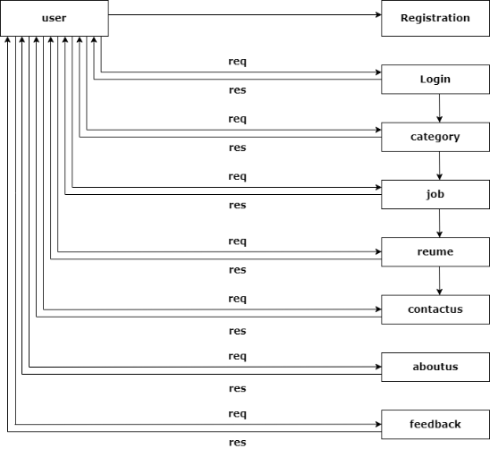

**LEVEL 2 DFD: -**

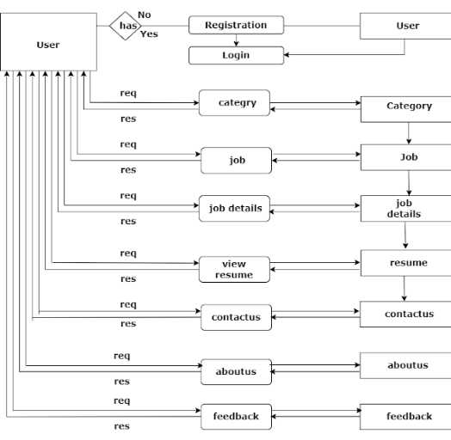

**Admin**

**Level 1 DFD: -**

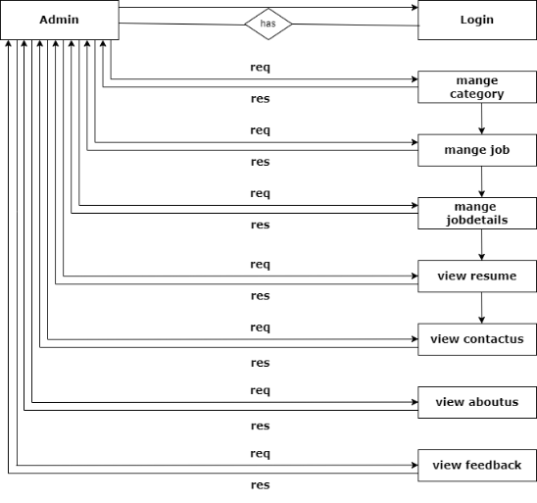

**Level 2 DFD: -**

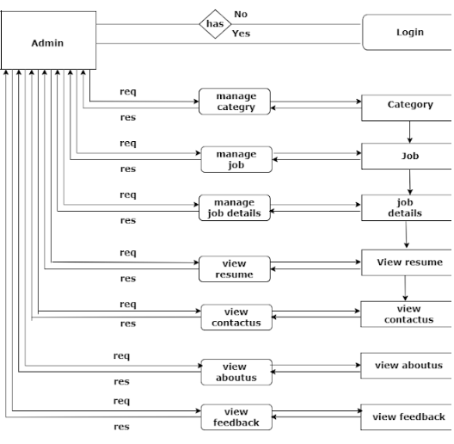

**C] ER Diagram:**

ER Diagram stand for Entity Relationship diagram, it shows the representation of entities, attributes sets and its attributes.

Entity:

An entity can be any object, cart, user or bill in ER Diagram. Entity can be represented using rectangle. Consider an example of entities on our project [registration form, admin, category, job, resume, feedback, contact us, about us]

Attributes:

Attributes describes property or characteristic of an entity, In ER Diagram entity can be represented using ellipse. Consider example of attributes in our project. [C_id, C_nm, C_img] for entity [category]

Relationship:

A relationship describes relations between entities, it can replace by diamond shapes and connected by a line.

1] one to one:

This type of relationship means one entity is associated with one number of some entity. This type of relationship is rarely seen in real world.

2] one to many:

This type of relationship means 1 entity is associated with many numbers of some entity.

3] many to many:

This type of relationship means many entities is associated with many numbers of same entity.

ER Diagram is a graphical method representing entity classes, attributes and relationship.

**An ER Diagram used six basic symbols:**

|  |  |  |
| --- | --- | --- |
| 1. | Rectangle: | Rectangle to denote any entity text. |
| 2. | Diamond: | Diamond to denote relationship between two entities. |
| 3. | Oval: | Oval to denote attribute. |
| 4. | Line: | Line which link attribute to entity or entity set and entity set two to relationship. |
| 5. | Single:  1 | ‘1’ to denotes single to occurrence. |
| 6. | Multiple:  M | ‘M’ to denotes multiple occurrences. |

**ER Diagram:**

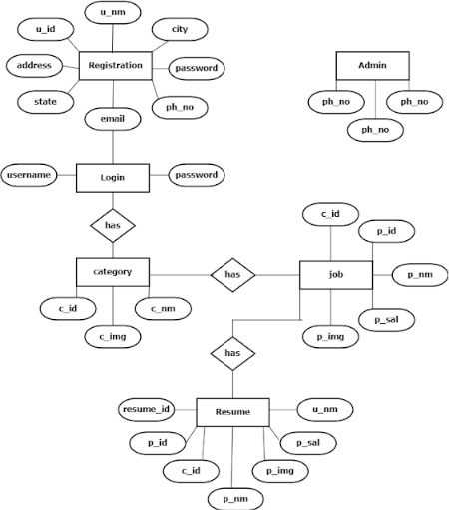

**D] Unnormalization:**

An Unnormalization Table is a table that does not meet the definition of relation.

It’s containing rows with multiple value for attributes or contains duplicate rows.

|  |  |  |
| --- | --- | --- |
| id | name | img |
| 1 | Web developer | dev.jpg |
| 2 | Web designer | des.jpg |
| 3 | Full stack development | stack.jpg |
| 4 | PHP | php.jpg |
| 5 | JAVA | java.jpg |
| 6 | HTML & CSS | css.jpg |
| 7 | BOOTSTRAP | boot.jpg |
| 8 | Animation | anm.jpg |
| 9 | GIM | gim.jpg |
| 10 | Graphics | gra.jpg |

**E] Normalization:**

Normalization is the process of organizing the columns and tables or relational database to reduce data redundancy and improve data.

It is also the process of simplifying the design of database so that optimal database structure.

It was first proposed by edger, code. As an integral part of relational model.

It involves arranging attribute in relation based on dependencies between attributes, ensuring that the dependencies are properly enforced by database integrating constraints.

It is accomplished by applying some formal either by process of synthesis or decomposition.

1] First Normal Form (1NF):

It is a property of relation in a relational database.

A relation is in First Normal Form if any domain of each attributes contains only invisible values and the value of each attribute contains only single value from the domain.

* **First Normal Form enforces these criteria:**

Eliminates repeating group in individual tables.

Create a separate table for each set of related data.

Identify each set of related data with a primary key.

* **The process by which we efficiently organized data to achieve goals:**

1. Eliminating Redundancy
2. Ensuring data is stored in correct table.
3. Eliminating need for restructure database when data is added.

Category

|  |  |  |
| --- | --- | --- |
| **C_id** | **C_nm** | **C_img** |
| 1 | Web Developer | C1.jpg |
| 2 | Web Designer | C2.jpg |
| 3 | UI/UX designer | C3.jpg |

2] Second Normal Form (2NF):

It is normal form used in database normalization.

Relation that is in 1nf must meet additional criteria if it is to qualify for second normal form.

**Specially:**

Relation is in 2nf if it is in 1nf and no non-prime attribute is dependent on any proper subset of any candidate key of relation.

Non-prime attribute of relation is an attribute that is not a part of any candidate key oh the relation.

|  |  |  |  |  |
| --- | --- | --- | --- | --- |
| **C_id** | **P_id** | **P_nm** | **P_image** | **P_sal** |
| 1 | 1 | PHP | Php.jpg | 5000 |
| 3 | 1 | Logo Maker | logo.jpg | 5500 |
| 1 | 2 | HTML | Html.jpg | 5900 |
| 3 | 2 | Mobile Interface | moblie.jpg | 10000 |
| 2 | 2 | SQL EXPERT | sql.jpg | 10000 |
| 1 | 3 | PYTHON | Python.jpg | 15500 |

Job

3] Third Normal Form (3NF):

Third Normal Form is a normal form that is in used in normalization a data design to reduce the duplicate of data and ensure referential integrate by insure that.

1. The entity is in second normal for and.
2. All the attributes in a table are data remind only by the candidate key of that relational and not by any non-prime attributes.

3NF was designed to improve database processing while minimizing storage cast.

3NF data modelling was ideal for online transaction processing (OLTP) application with heavy order enter type on needs.

4] Boyce – Codd Normal Form (BCNF):

Boyce-Codd Normal Form (or BCNF or BSNF) is a normal form used in database normalization.

It is slightly stranger version of the 3 Normal Form (3NF).

BCNF was developed to address certain types of a normalize not default with by 3NF as originally defined.

If a relational schema is in BCNF then all redundancy has been on functional dependency has been removed, although other types of redundancy may still exist.

**Client Side**

Home

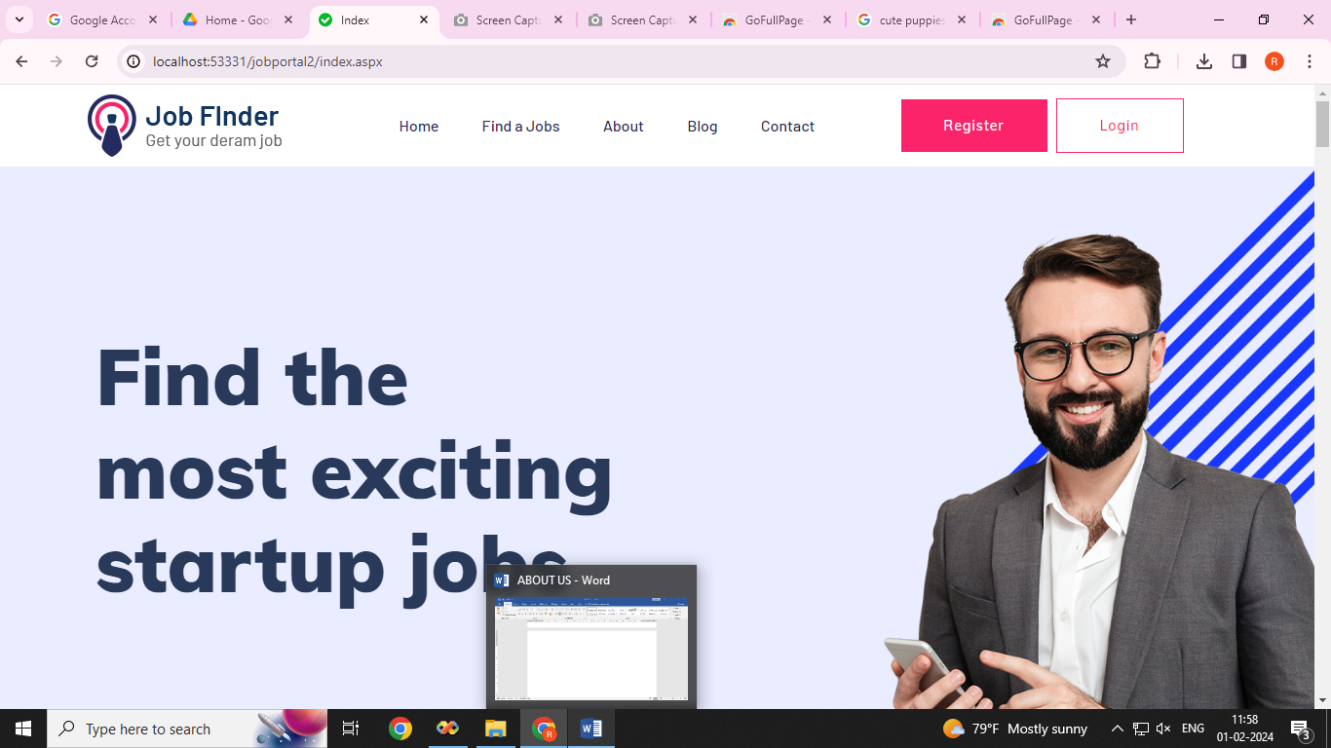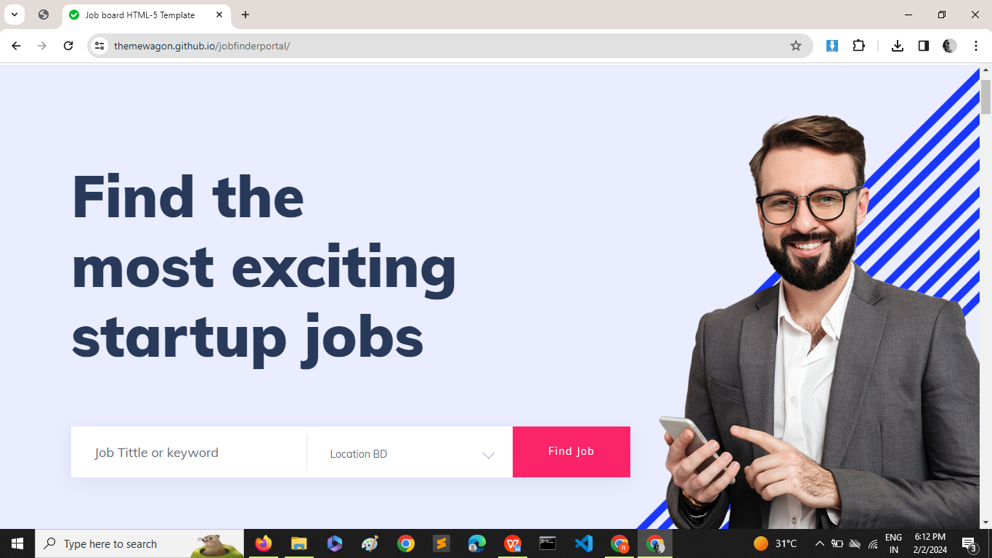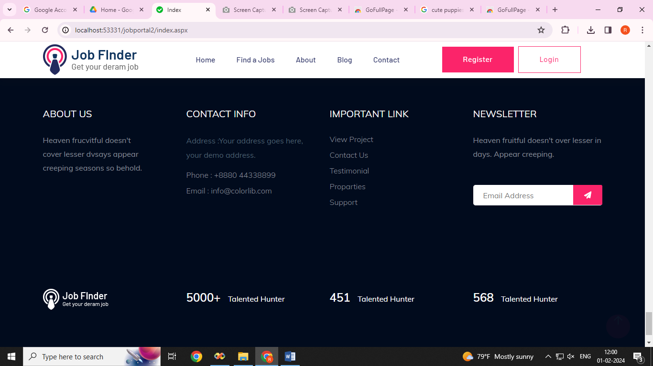

ABOUT US

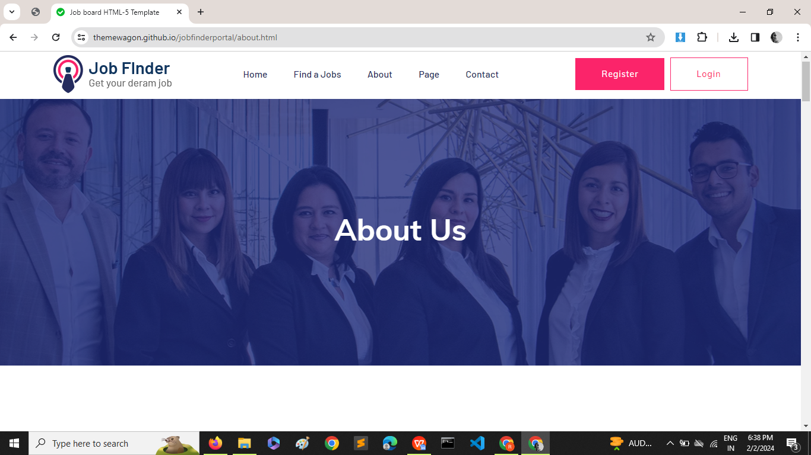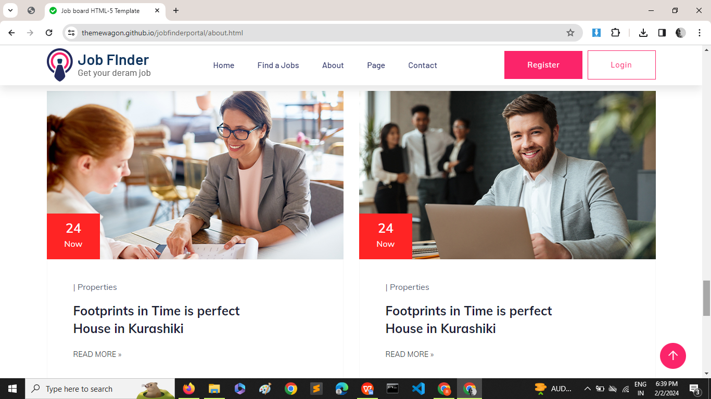

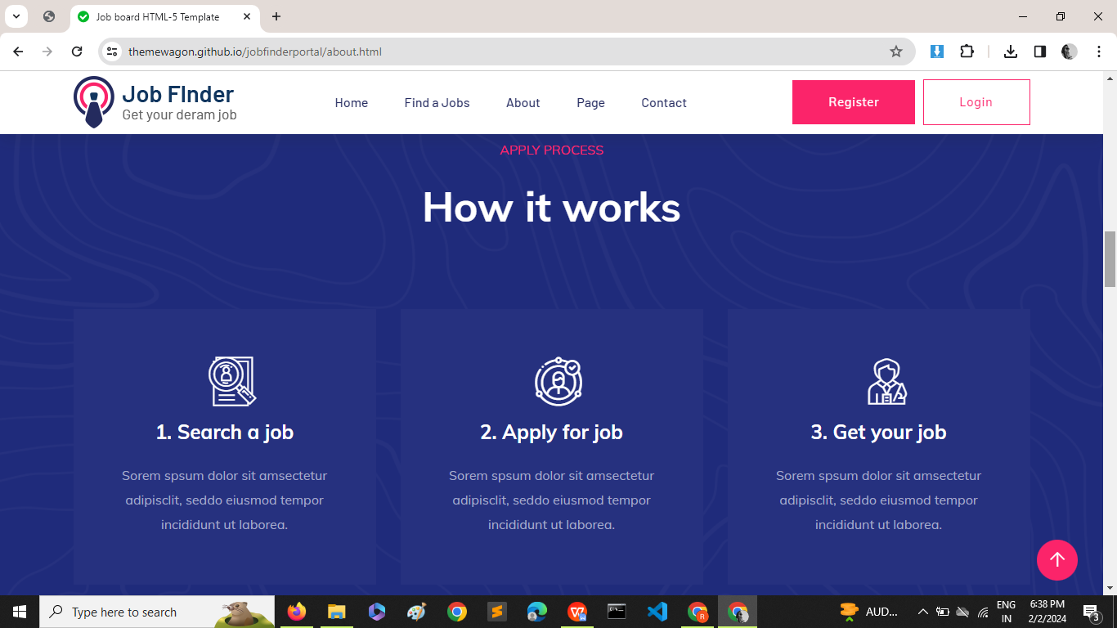

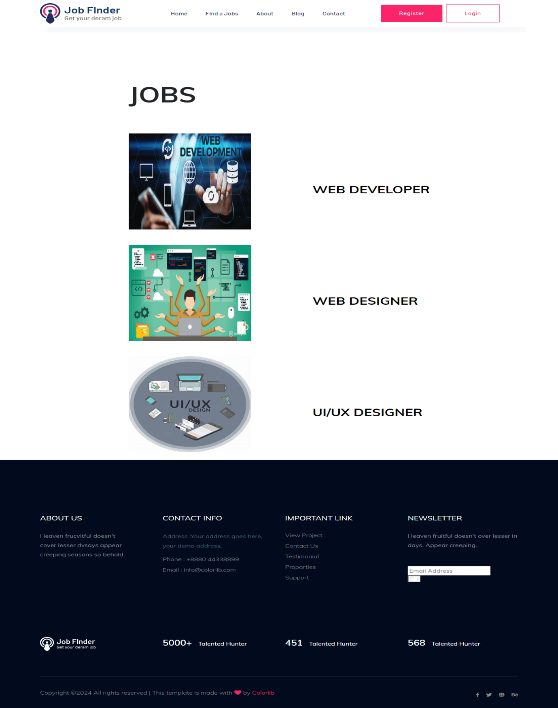CATEGORY

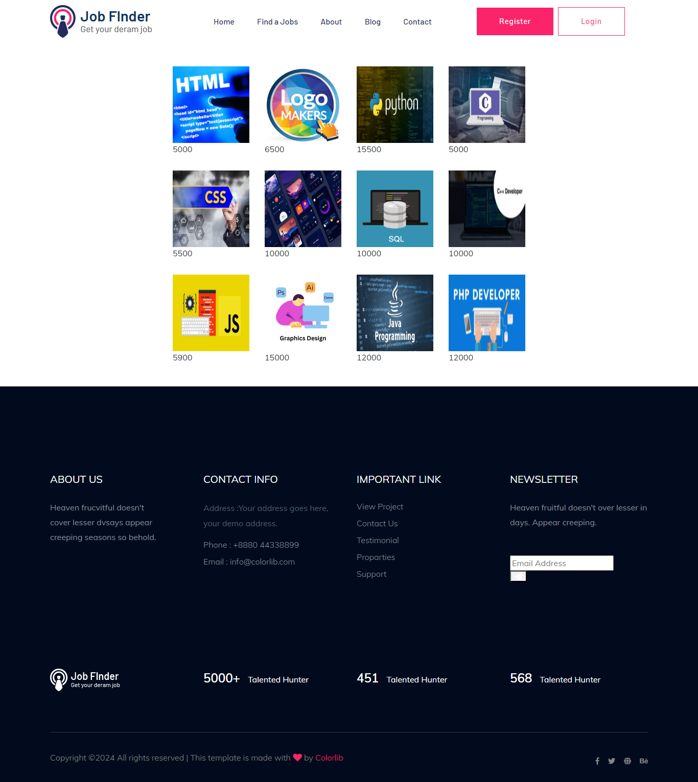JOBS

JOB DETAILS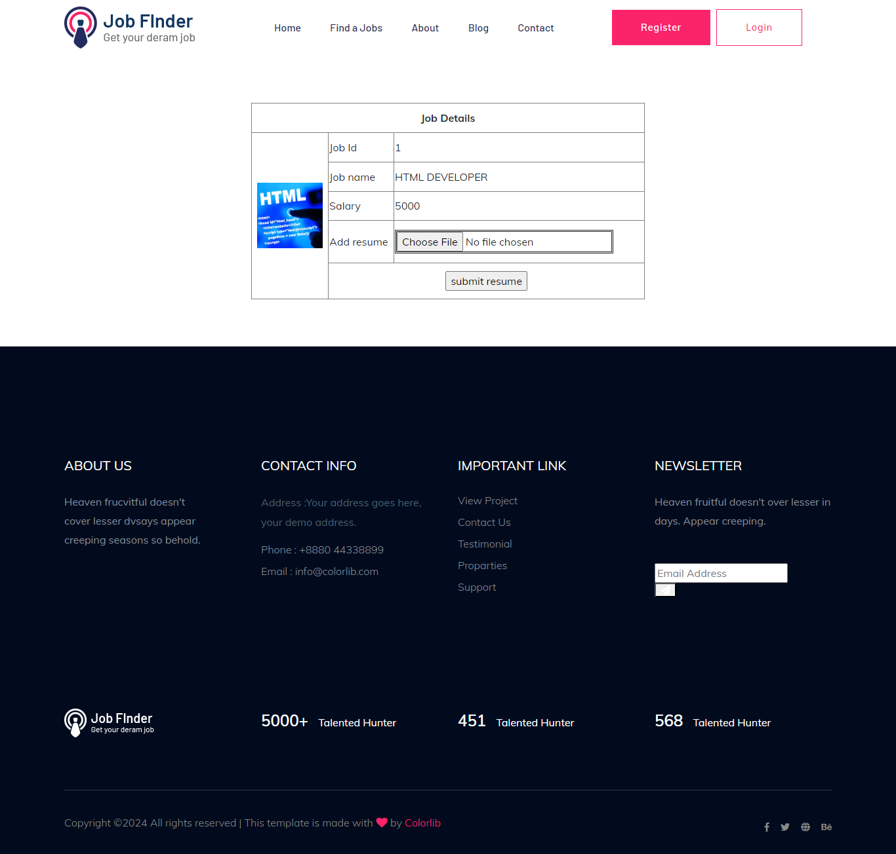

REGISTRATION PAGE

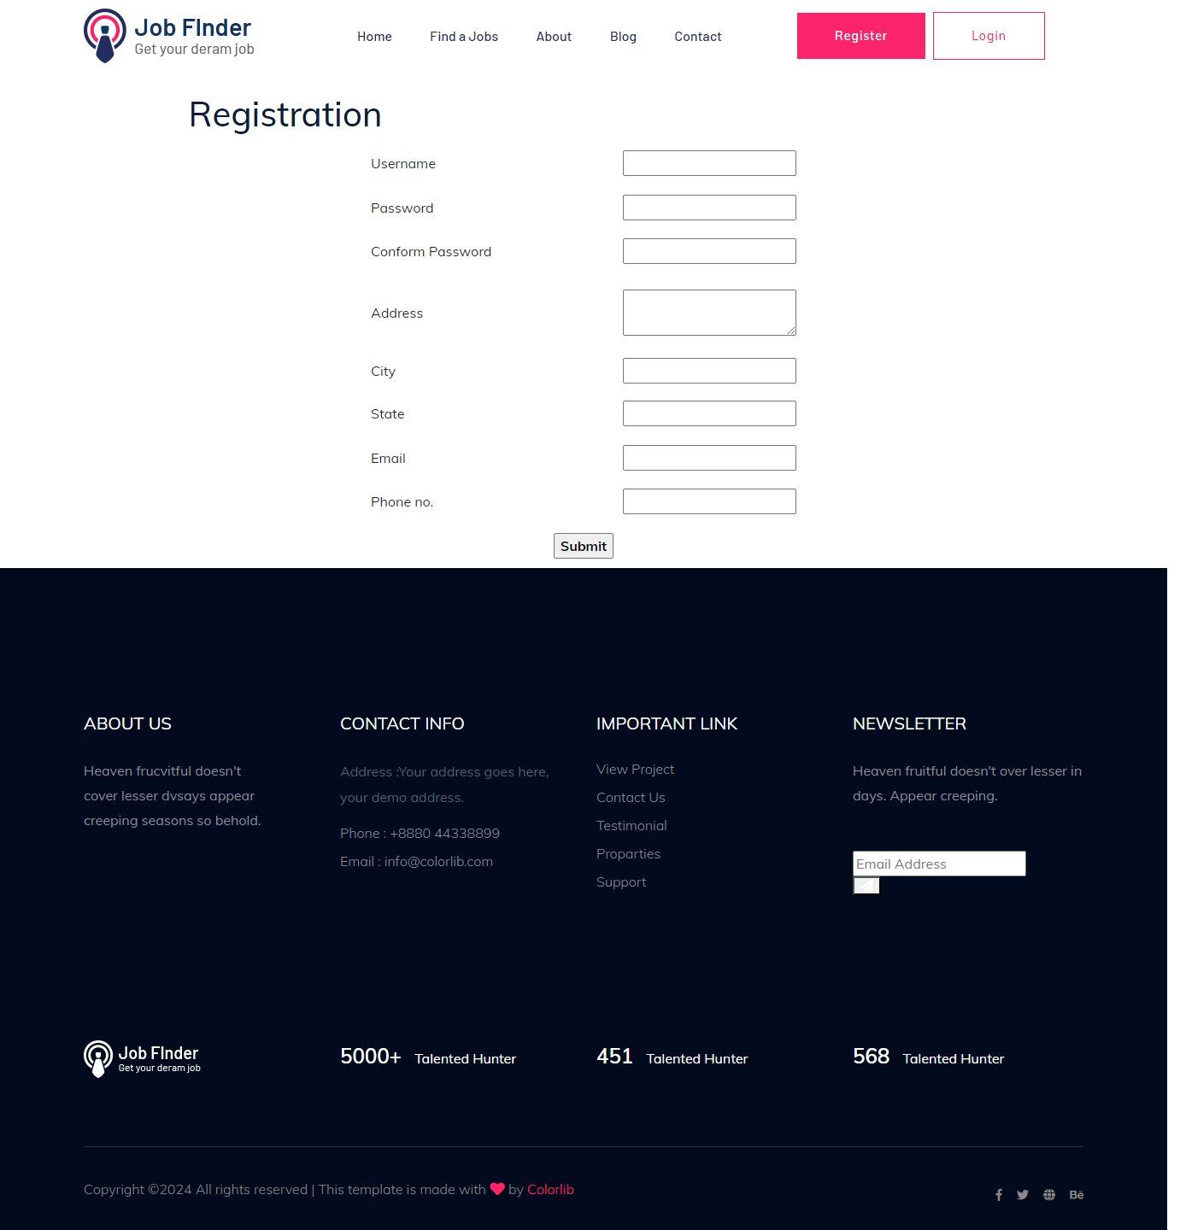

LOGIN PAGE

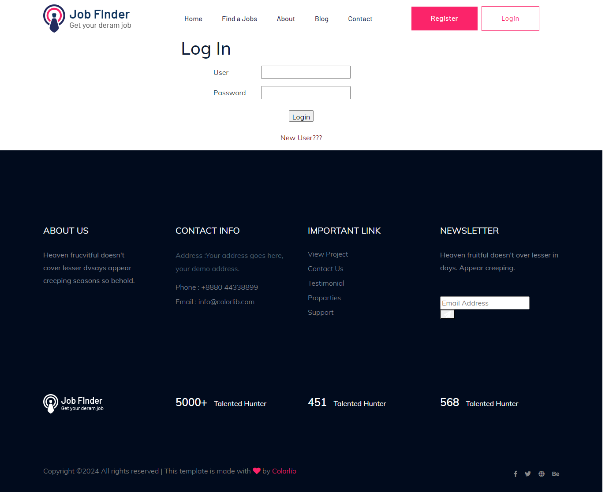

THANK YOU

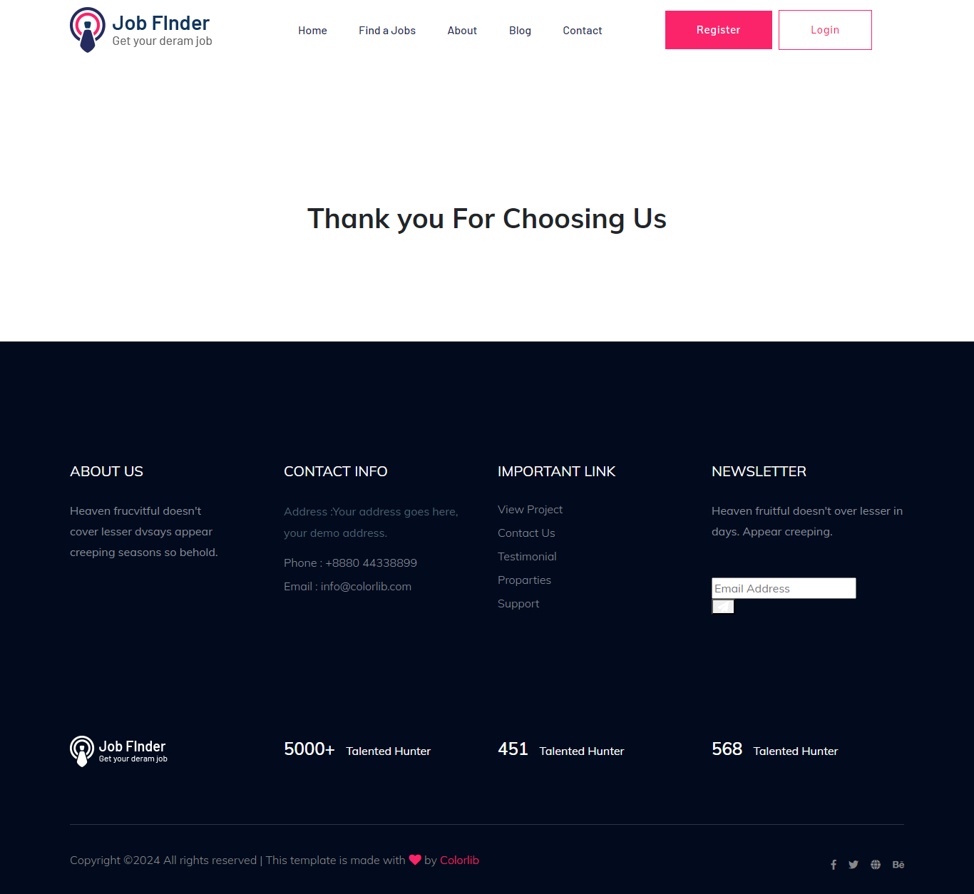

**ADMIN SIDE**

ADMIN HOME

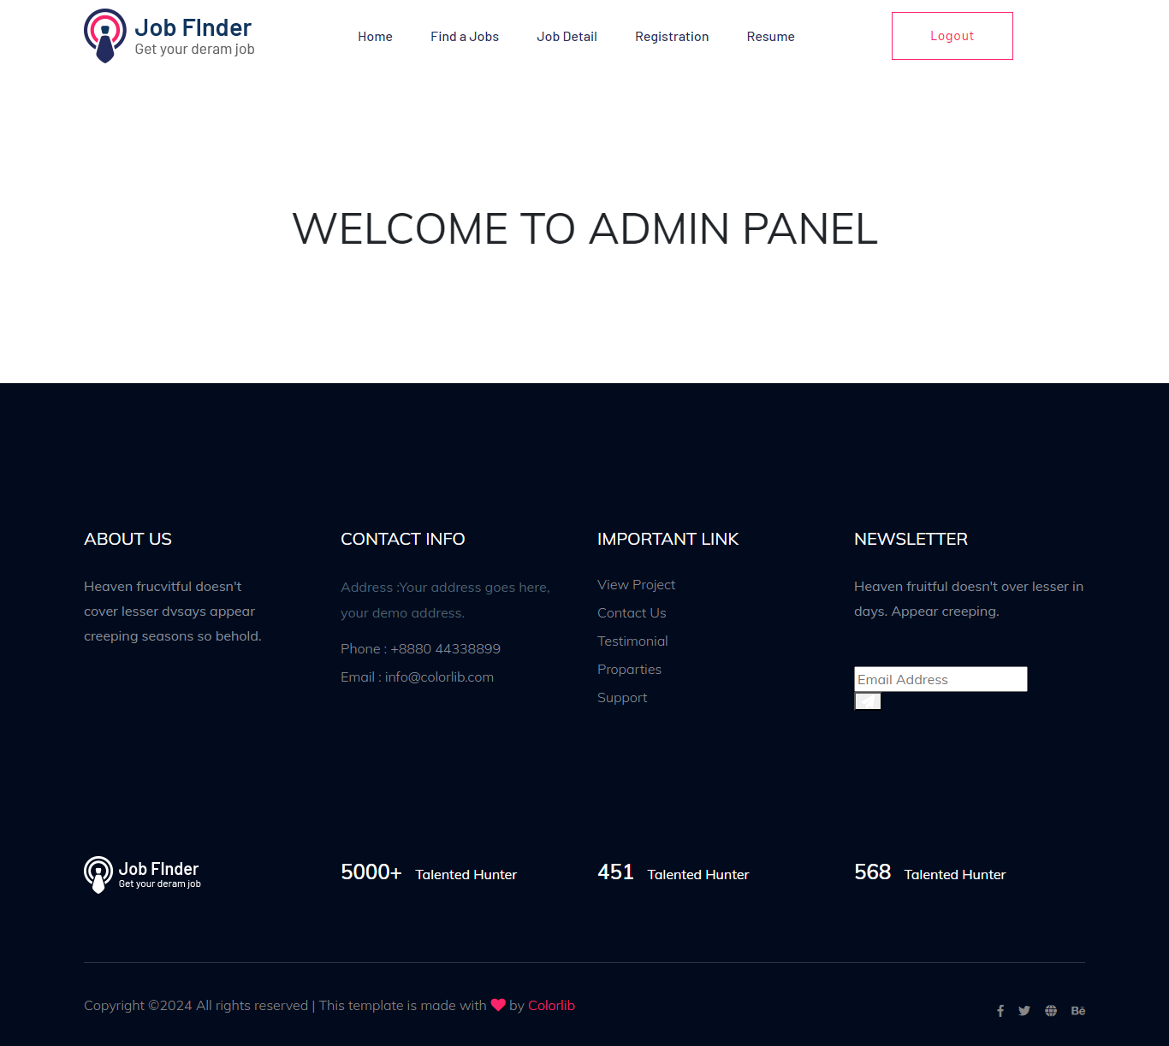

ADD CATEGORY

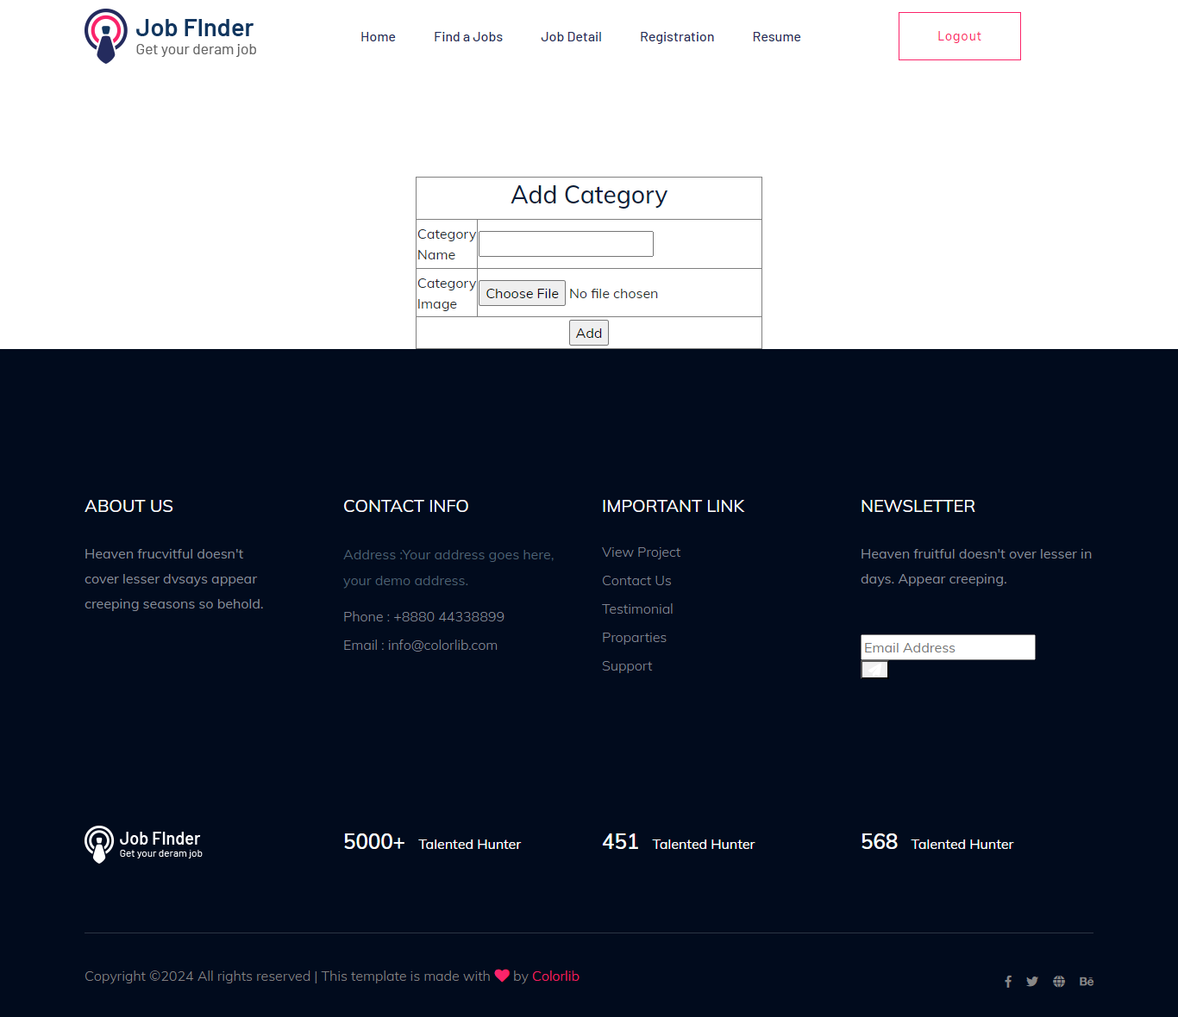

EDIT CATEGORY

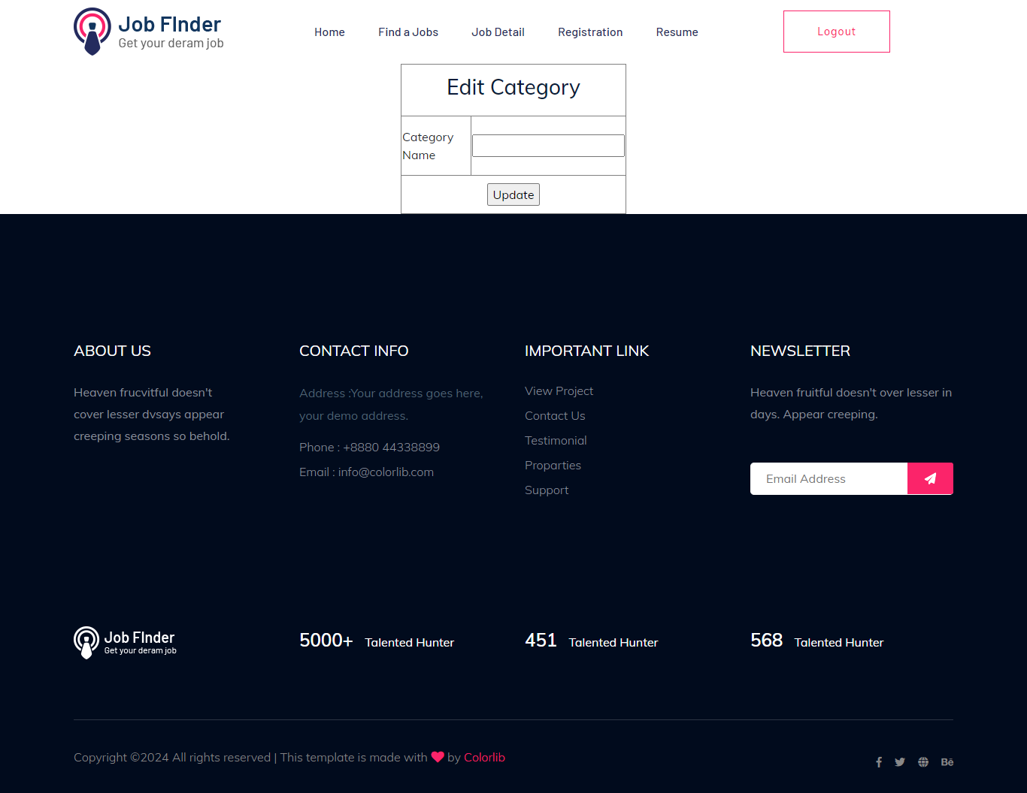

ADD JOBS

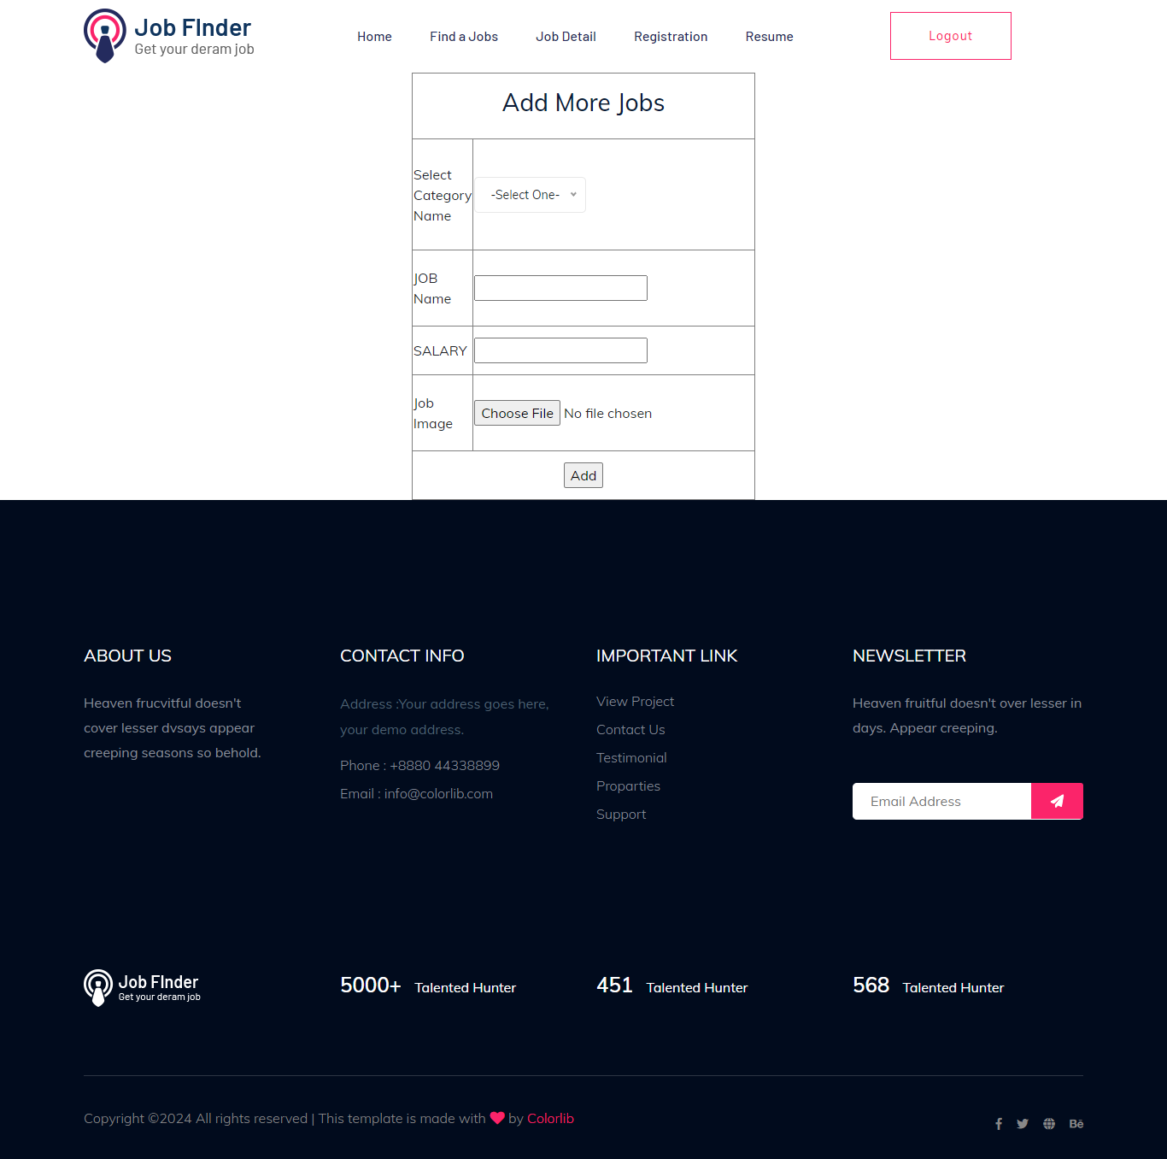

REGISTRATION

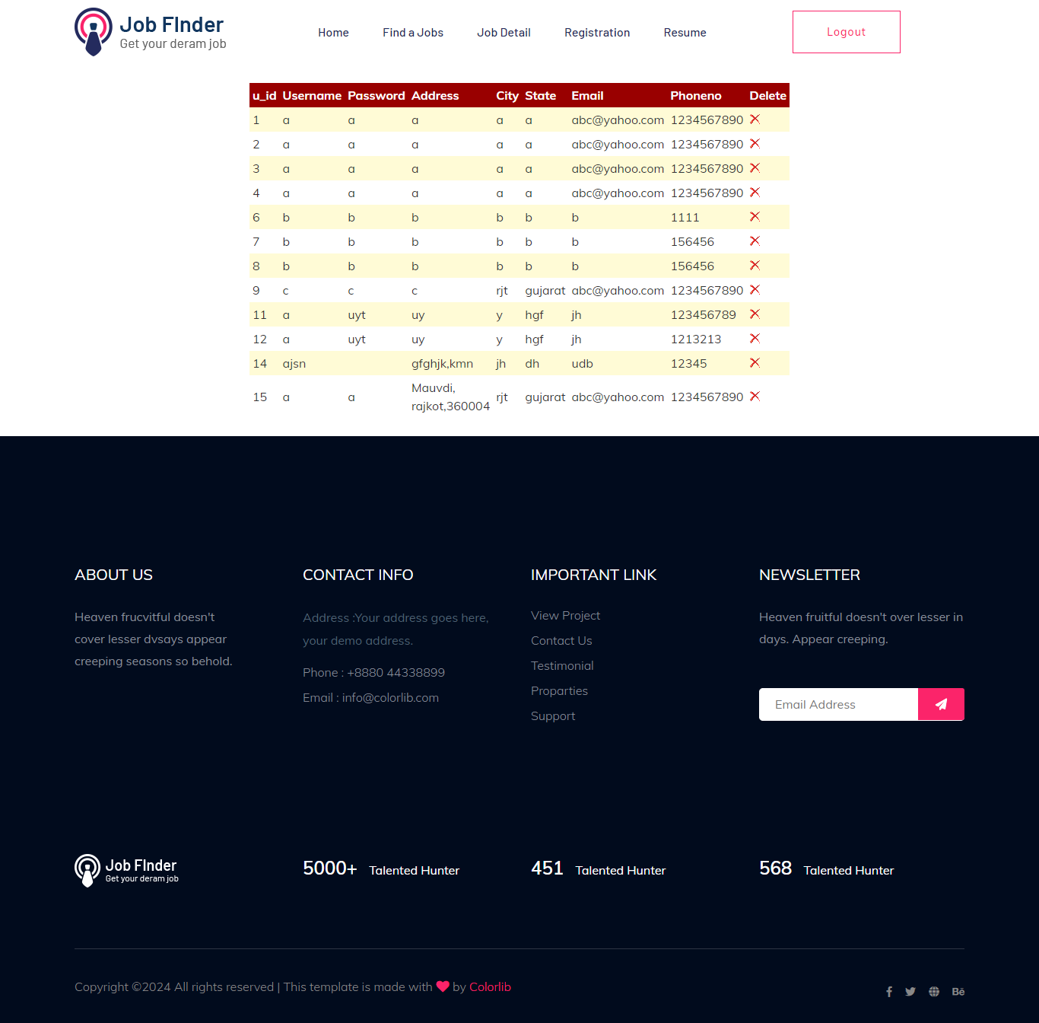

RESUME



System Testing

The important and essential part of system development phase. After designing and developing the software is system testing.

We cannot say that every program system is perfect because of luck of communication between the user and the software development.

This is a time when all the system are gathered into are gathered into one pool and test whole system to determine wherever it meets the user requirements.

Testing is important function to the success of the system.

There are three techniques of software testing:

***White Box Testing:***

This type of testing required the knowledge of internal structure of software which is clearly visible to programmer so it is known as White Box Testing.

This is also known as Glass Box, Structured Clear Box and Open Box Testing.

White Box System Testing is performed by development team and programmer.

***Black Box Testing:***

This method is named black box because the software programmer in the eyes of the tester is like a black box, inside which are cannot see.

It is also called behaviour / functional testing.

It is performed by software engineers.

Tester compares real output with the expected output per success of testing process.

***Grey Box Testing:***

Grey Box Testing is combination of Black Box Testing and White Box Testing.

It is also known as Translate Testing.

***Manual Testing:***

Manual Testing is process which is done manually.

All the famous phase of STLC like test planning, test deployment, result analyses, test execution, buy tracking and reporting tools are obviously coming under the category of manual testing and done successfully by human efforts.

Manual Testing is a start of testing without this testing we cannot start automation testing.

In normal testing we find more buss than automation by error quashing.

* It takes lots of time.
* Manual Testing would be run sequentially.
* Regression Testing process is though in Manual Testing.
* It is not expensive.

More testers are required is in manual testing because in this test

need to be executed manually.

* It gives low accuracy result.
* It is considering as low quality.
* In this testing we cannot do batch testing.
* It is considered as less reliable.
* No need of programming in manual testing.
* It is dined without interaction of any tool.

***Automation Testing:***

Automation Testing is process which is done by the help of automated tools.

In automation Testing all the popular phase of SDLC are none by various open source and purchased tools like selenium

1 meter, QTP, Load Runner with Runner and so on.

Automation Testing is continuous part of Manual Testing.

In Automation Testing we test the relative functionalities of the Application.

* It takes less time.
* It is done on different machines at same time.
* Regression Testing process is easy in Automation Testing by tools.
* It is expensive.

Few testers are required in Automation Testing because this testing test case need to be executed by using automation tools.

* It gives high accruals result.
* It is considering as high quality.
* In this testing we can do multiple types of Batch Testing.
* It is considered as more reliable.
* Need of programming is must in Automation Testing.
* It is always done using tools.

ADVANTAGES

* Job Seeker don’t need to stand in big queue for getting a job.
* By doing this, seeker can save their time.
* Job seeker can apply for job online as per their time requirement.
* Using JOB FINDER privacy can maintain.
* User get high opportunities in different domains.
* User can search any it jobs without paying fees.

Disadvantage

* Applying for jobs Online can be time consuming tedious process.
* The hiring process itself maybe slow and it may take you a while to hear more about your application status.
* It also difficult to find candidates with Exact skillsets.
* It takes several times to search through profile.

FUTURE ENHANCEMENT

* JOB FINDER will be ready to face challenges from social media and professional networking site.
* Job boards needs to figure out what are the gaps and modify strategies that can make them more popular for job seekers & employees.
* The future generation relies more on digital networking tools to look for job searches.
* Easy accessibility to digital tools & techniques can help establish better connections which make the JOB FINDERs remains on the competitive edge.
* JOB FINDER provides service to the job applicants to search for working opportunities.
* JOB FINDER will allow job provider to establish one to one relationship with candidates.

* This Portal will primarily focus on the posting and management of job vacancies.

REFERENCE

* **WEBSITES:**

[**http://www.MySQL.com**](http://www.MySQL.com)

[**www.google.com**](http://www.google.com)

[**http://www.Net.com**](http://www.Net.com)

[**http://www**.**C#friend.com**](http://www.C#friend.com)

**http://www.ASPVirtual.com.in**

* **REFERENCE:**

[**WWW.LINKED.COM**](http://WWW.LINKED.COM)

[**WWW.NOKRI.COM**](http://WWW.NOKRI.COM)

* **SEARCH ENGINES:**

[**WWW.GOOGLE.COM**](http://WWW.GOOGLE.COM)

[**WWW.BING.COM**](http://WWW.BING.COM)